Explore

Case Processing Summary
 | Cases
 | Valid |  | Missing |  | Total
 | N | Percent | N | Percent | N | Percent
Optimism-Pessimism | 40 | 100.0% | 0 | .0% | 40 | 100.0%
Skill Level | 40 | 100.0% | 0 | .0% | 40 | 100.0%
Noxious Task Performance | 40 | 100.0% | 0 | .0% | 40 | 100.0%

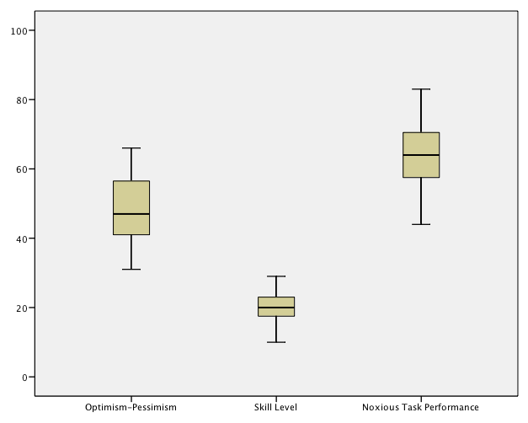

Correlations

Correlations
 |  | Optimism-Pessimism | Skill Level | Noxious Task Performance
Optimism-Pessimism | Pearson Correlation | 1.000 | .024 | .387*
Optimism-Pessimism | Sig. (2-tailed) |  | .882 | .014
Optimism-Pessimism | N | 40.000 | 40 | 40
Skill Level | Pearson Correlation | .024 | 1.000 | -.503**
Skill Level | Sig. (2-tailed) | .882 |  | .001
Skill Level | N | 40 | 40.000 | 40
Noxious Task Performance | Pearson Correlation | .387* | -.503** | 1.000
Noxious Task Performance | Sig. (2-tailed) | .014 | .001
Noxious Task Performance | N | 40 | 40 | 40.000
*. Correlation is significant at the 0.05 level (2-tailed).
**. Correlation is significant at the 0.01 level (2-tailed).

Graph
